DESIGN A WEB INTERFACE FOR ONLINE BANKING SYSTEM

Aim: To design a web interface for online banking systems using balsamiq design software

Procedure:

**Step 1: Understand the Requirements**

Before you start designing, make sure you have a clear understanding of the features and functionalities required for the online banking system. This may include user authentication, account overview, fund transfers, transaction history, bill payments, and more.

**Step 2: Start a New Project**

1. Launch Balsamiq.
2. Create a new project with a suitable canvas size (e.g., desktop or mobile resolution).

**Step 3: Design the Main Layout**

1. Begin with the main layout, which typically includes a header, sidebar or navigation, and a content area.
2. Use simple shapes (rectangles, text boxes, buttons) to represent each of these elements.
3. Arrange them in a clean and intuitive manner.

**Step 4: Design Key Pages**

Design the following key pages, keeping the overall user flow in mind:

1. **Login Page**:
   * Include fields for username and password.
   * Add a "Login" button.
   * Consider including a "Forgot Password" link.
2. **Account Overview Page**:
   * Display account balances.
   * Show recent transactions.
   * Include navigation to other sections.
3. **Transfer Funds Page**:
   * Provide fields for selecting source and destination accounts.
   * Include an amount field.
   * Add a "Transfer" button.
4. **Transaction History Page**:
   * Display a list of past transactions.
   * Include filters and sorting options.
5. **Bill Payments Page**:
   * Allow users to select the biller.
   * Include fields for entering payment details.
   * Add a "Pay" button.

**Step 5: Use Balsamiq Components**

Take advantage of Balsamiq's pre-built components to create a more realistic and consistent design. Customize the components to match the branding and overall look of an online banking system.

**Step 6: Maintain Clarity and Simplicity**

1. Use clear and concise labels.
2. Maintain a clean and consistent visual style.
3. Prioritize user-friendly interactions.
4. Ensure the design is responsive if you're designing for multiple screen sizes.

**Step 7: Review and Iterate**

1. Review the wireframes/mockups for usability and completeness.
2. Gather feedback from stakeholders or potential users.
3. Iterate on the design based on the feedback received.

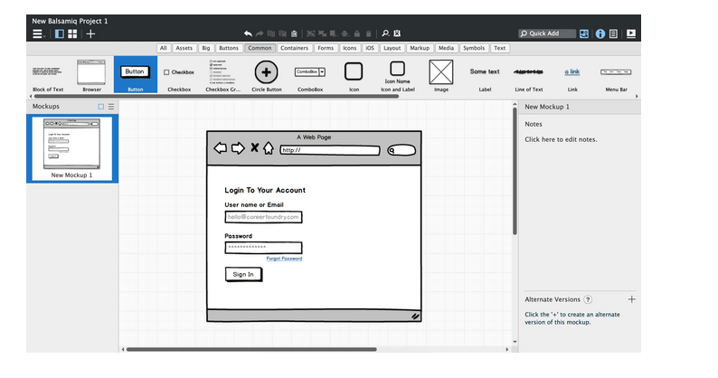

Result: Thus a web interface for online banking systems using balsamiq design software

has been designed .